# **Imp Tags**

# **Div**

# **span element**

<p>My mother has <span style="color:blue;font-weight:bold">blue</span> eyes and my father has <span style="color:darkolivegreen;font-weight:bold">dark green</span> eyes.</p>

|  |
| --- |

Output:

My mother has blue eyes and my father has dark green eyes.

---------------------------------------------------------------------------------------------------------------------------------------

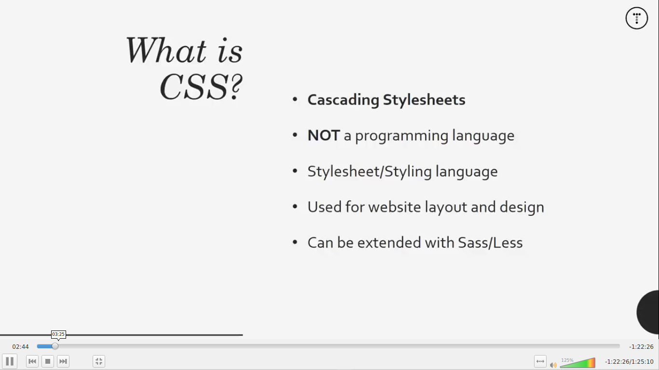**CSS**

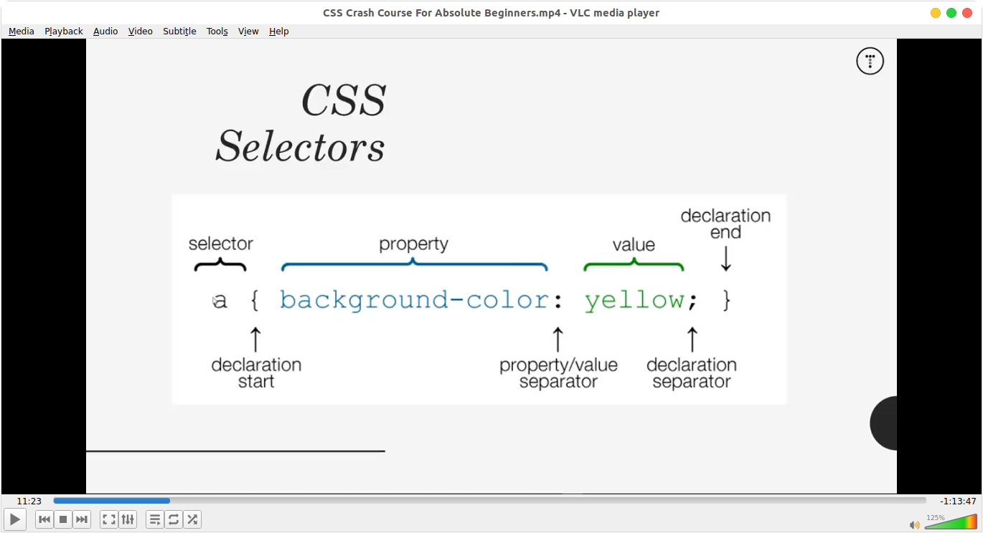

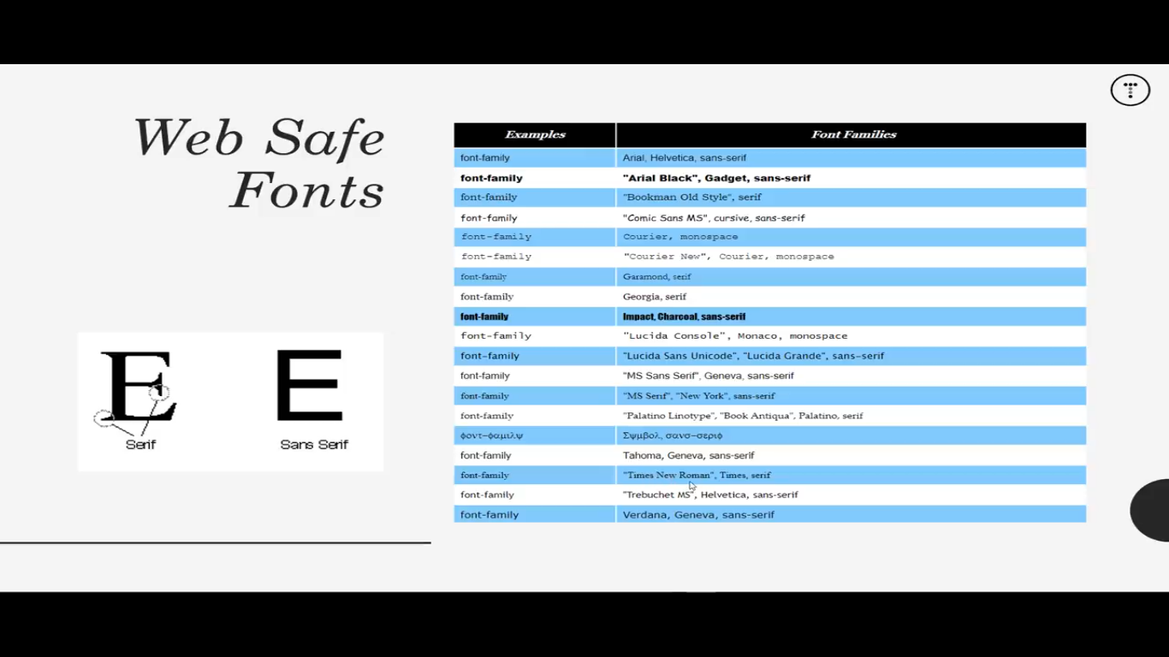**Difference between Class ans ID in HTML**

**Class=mostly we use it if we want to use this functionality at another place we uses this (access in CSS by .class_name)**

**&**

**ID = it used for uniqueness and here the concept is we are not going to use properties any where else**

**========================================================**

**In case of padding or margin use that value in “%” (eg: 80%) ======> make site responsive**

**=============================**

|  |  |
| --- | --- |
| **Margin**  .spacing from outside of the text | **Padding**  .spacing of text from inside |

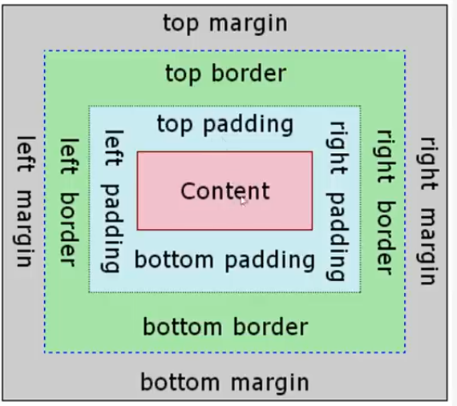

**---------------------------------------------------------------------------------------------------------------------------------------**

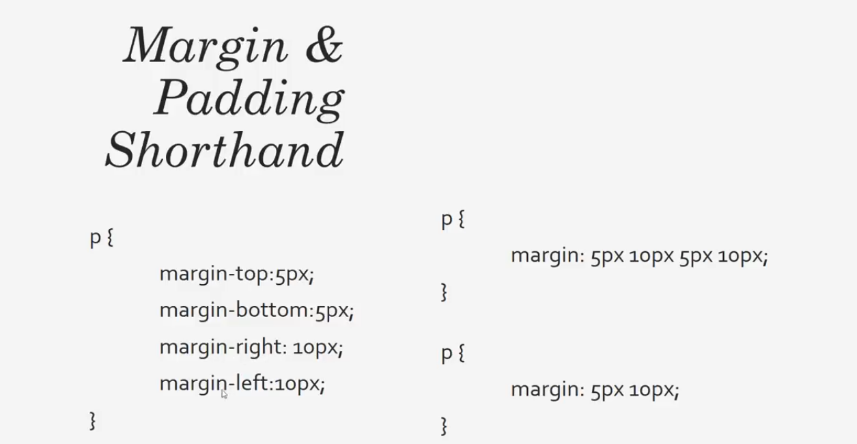**Margin or padding syntax =====> “same”**

**------------------Margin-------------------**

**=>one side manually:**

**border-right:5px red solid Or border-right-style:5px red dotted**

**=>on all sides with one line if we want same properties margin**

**border: 5px red solid (no need of direction mention)**

**==============================================================================**

|  |
| --- |
| Syntax =====> *{  //anything inside this tag overwrite its properties to all over web page  } |

**.class_name h1 {**

**//to target specific attribute inside the class**

**//in it we are targeting the h1 heading to contain according to our properties**

**}**

**=========================================================**

**\*\*\*\*\*\*\*\*\*\*\*\*\*\*\*to give square rounded border syntax = > border-radius: 15px;**

**============================================================**

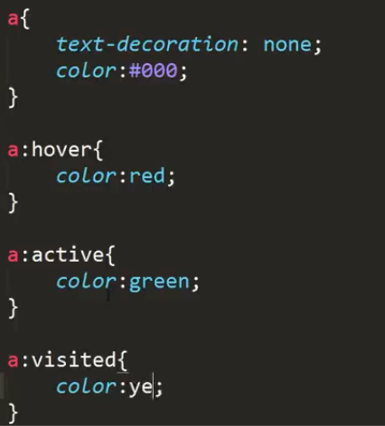**--->this is global tags for links mean where links come on page will contain these properties additionally======> syntax ====a{.property.}**

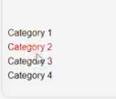

Black

**\*\*\*\*\*\*here hover,, active ,, visited these are the action if links get touched ---------------------------------------------------------------------------------------**

**before After=>**

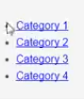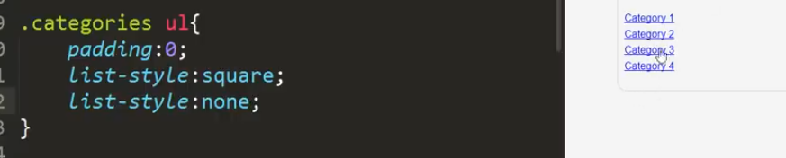 **---------------------------------------------------------------------------------------------------**

**also we can create button properties in global which will be usable other place as well**

**Form**

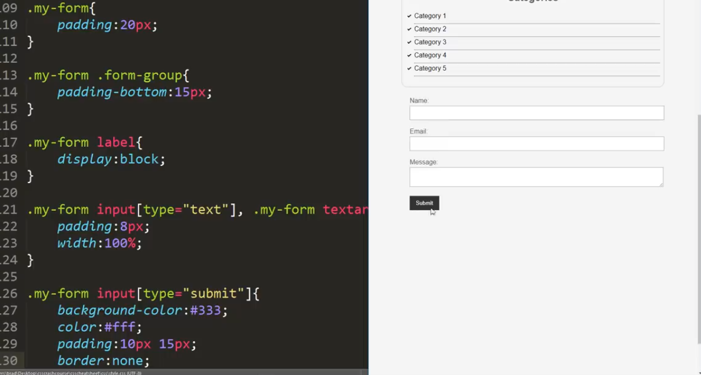**we can create hover effect on button as well**

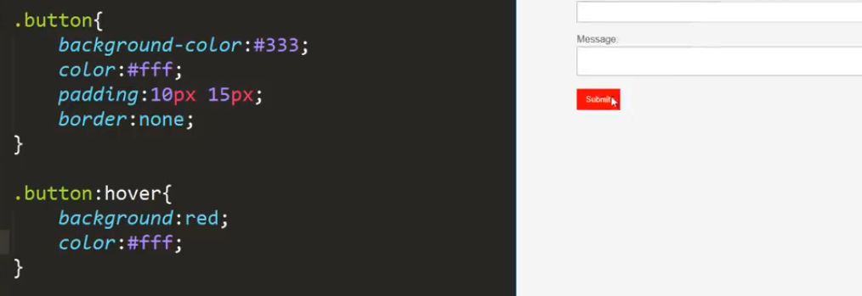**--------------------------------------------------------------------------------------------------------------------------------**

**==>working on blocks which are in a row**

**float==> making block horizontally**

**adding size**

**mostly we add padding or margin functionality it wrong behave for sol syntax used this is**

**border-sizing: border-box → make borders equal size**

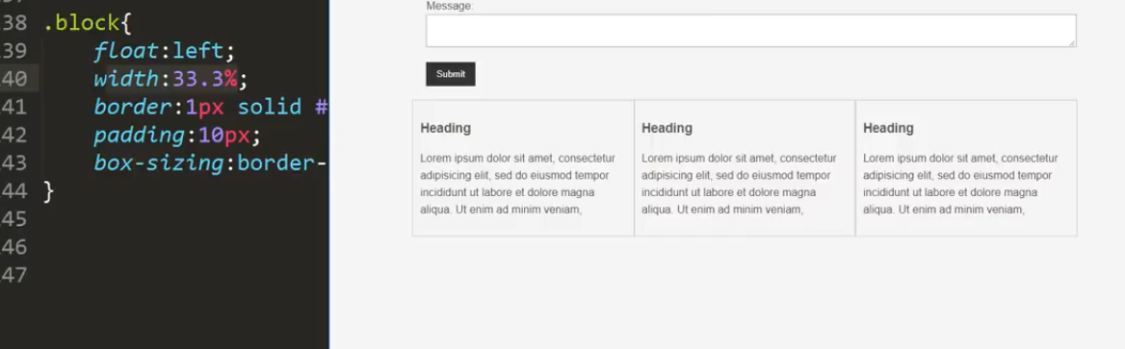**============================================================================**

box

**Main block working**

**DIV “Id”**

**to access it in CSS syntax will be**

**#class_name {**

**}**

**----------------------------------------------**

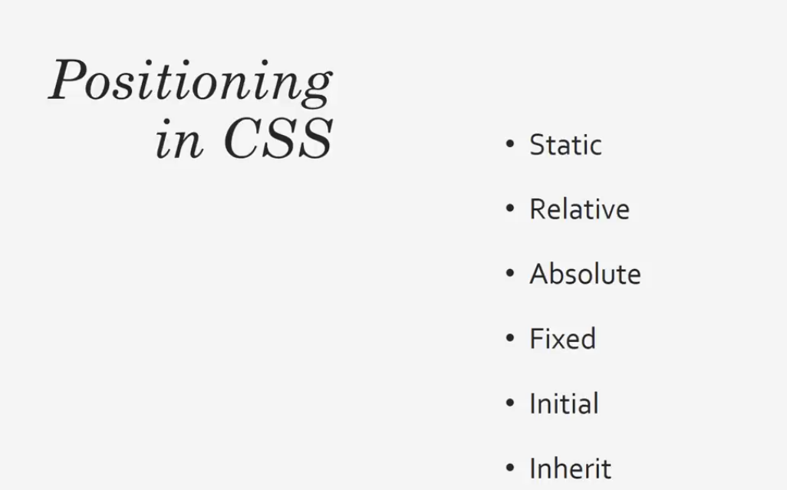

**here we have use 2 headings which are placed relative position of the box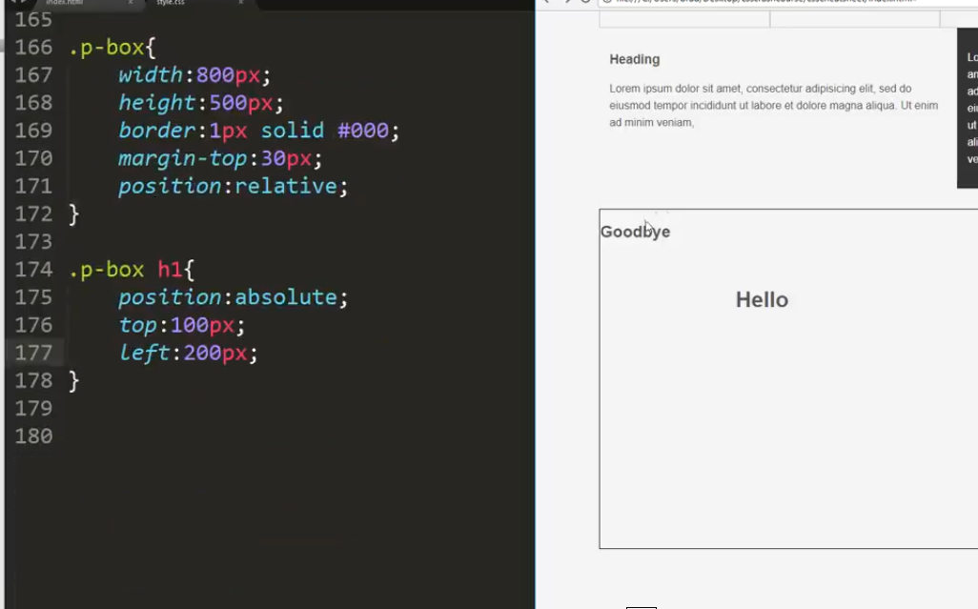 ------------------------------------------------------**

**how to paste any picture in any place according that shape ?**

**==============================================================================**

**Targeting pseudo classes**

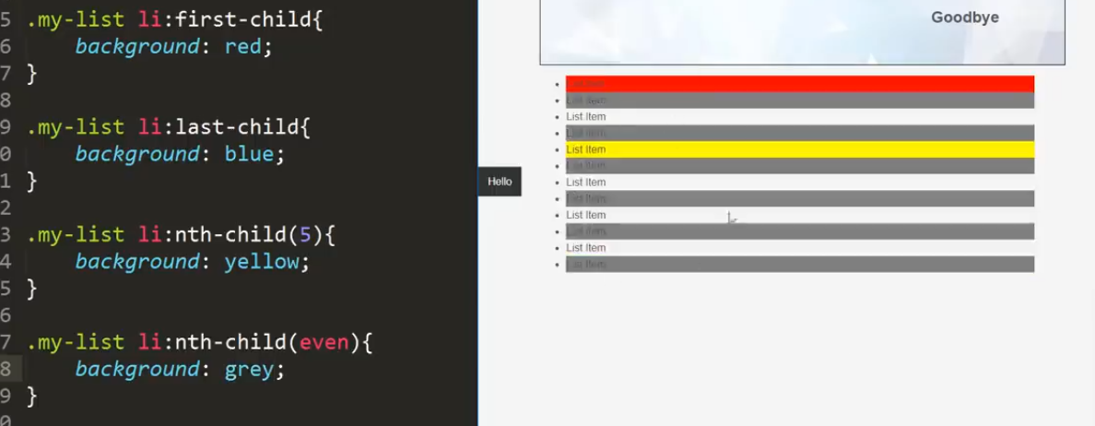

**“overriding issue(if width is too shorter)”**

**@media(condition){**

**on which apply**

**}**

**after the float element use<div class="clr"></div> in css add class==>> .clr{clearboth}**

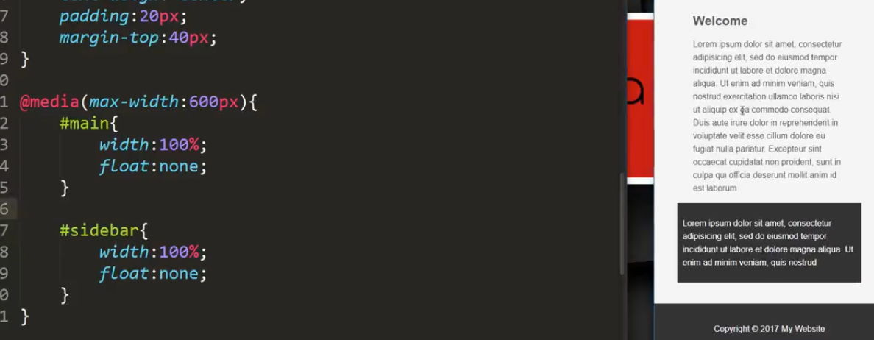

**Learning concepts:**

* **fonts working**
* **padding**
* **Margin**
* **links related==> (active , visited, hover)**
* **hover effect**
* **blocks creation + border creation**
* **positioning of text**
* **pseudo classes**